{"actId":"3","siteId":"1234","activityNo":"1002","reProcess":false,"stageByDateTime":"2020-09-11T08:35:31Z","storageTypes":["FZ","CH","AM"],"alternateIdNbr":"5463834","fulfillmentSystemId":"ACUPICK","facilityType":"STORE","shiftNo":"1","timezone":"America/Los_Angeles","events":[{"activityType":"PICK_PACK","eventId":"ACTIVITY_RELEASED","eventDateTime":"2020-09-11T09:38:01.229Z"},{"activityType":"PICK_PACK","eventId":"ACTIVITY_STARTED","eventDateTime":"2020-09-11T09:40:03.522Z"},{"activityType":"PICK_PACK","eventId":"USER_ASSIGNED","eventDateTime":"2020-09-11T09:40:03.555Z"},{"activityType":"PICK_PACK","eventId":"ACTIVITY_COMPLETED","eventDateTime":"2020-09-11T09:55:49.392Z"},{"activityType":"DROP_OFF","eventId":"ACTIVITY_COMPLETED","eventDateTime":"2020-09-11T09:58:44.515Z"}],"itemActivities":[{"itemId":"113150015","itemDescription":"BC COOKIE MIX PEANUT BUTTER","fulfillmentOrderNo":"02","customerOrderNo":"02","orderedQty":5,"itemLocation":{"aisle":"DA","side":"L","bay":"02","level":"004"},"subAllowed":true,"subCode":"2","subValue":"Same Brand Diff Size","pickedItems":[{"containerId":"2","isSubstitution":false,"substitutionItemId":null,"substitutionItemDesc":null,"upc":"0003663202631","upcQty":1,"fulfilledQty":1,"pickedTime":"2020-09-11T09:42:27.554Z"},{"containerId":"2","isSubstitution":false,"substitutionItemId":null,"substitutionItemDesc":null,"upc":"0003663202632","upcQty":1,"fulfilledQty":1,"pickedTime":"2020-09-11T09:42:27.554Z"},{"containerId":"3","isSubstitution":false,"substitutionItemId":null,"substitutionItemDesc":null,"upc":"0003663202633","upcQty":1,"fulfilledQty":1,"pickedTime":"2020-09-11T09:42:27.554Z"}],"shortedItems":[{"exceptionReasonCode":"Damaged","exceptionQty":4,"exceptionDateTime":"2020-09-11T09:55:49.099Z"}]},{"itemId":"102013665","itemDescription":"M&M 3 MUSKETEERS FUN SIZE","fulfillmentOrderNo":"02","customerOrderNo":"02","orderedQty":5,"itemLocation":{"aisle":"DA","side":"R","bay":"15","level":"002"},"subAllowed":true,"subCode":"2","subValue":"Same Brand Diff Size","pickedItems":[{"containerId":"2","isSubstitution":false,"substitutionItemId":null,"substitutionItemDesc":null,"upc":"0003663202631","upcQty":1,"fulfilledQty":1,"pickedTime":"2020-09-11T09:42:27.554Z"}],"shortedItems":[{"exceptionReasonCode":"Damaged","exceptionQty":4,"exceptionDateTime":"2020-09-11T09:55:49.127Z"}]},{"itemId":"136300423","itemDescription":"DANNON ACTIVIA YOGURT LIGHT VANILLA","fulfillmentOrderNo":"02","customerOrderNo":"02","orderedQty":5,"itemLocation":{"aisle":"DA","side":"L","bay":"18","level":"001"},"subAllowed":true,"subCode":"2","subValue":"Same Brand Diff Size","pickedItems":[{"containerId":"3","isSubstitution":false,"substitutionItemId":null,"substitutionItemDesc":null,"upc":"0003663202631","upcQty":1,"fulfilledQty":1,"pickedTime":"2020-09-11T09:42:27.554Z"}],"shortedItems":[{"exceptionReasonCode":"Damaged","exceptionQty":4,"exceptionDateTime":"2020-09-11T09:55:49.141Z"}]},{"itemId":"960560970","itemDescription":"80% Lean Beef Patties 1/3 Lb 20% Fat - 2 Lb","fulfillmentOrderNo":"02","customerOrderNo":"02","orderedQty":5,"itemLocation":{"aisle":"DA","side":"L","bay":"08","level":"003"},"subAllowed":true,"subCode":"2","subValue":"Same Brand Diff Size","pickedItems":[],"shortedItems":[{"exceptionReasonCode":"Damaged","exceptionQty":5,"exceptionDateTime":"2020-09-11T09:55:49.159Z"}]},{"itemId":"148020408","itemDescription":"Foster Farms Honey Crunchy Flavor Corn Dogs - 16 Count","fulfillmentOrderNo":"02","customerOrderNo":"02","orderedQty":5,"itemLocation":{"aisle":"DA","side":"R","bay":"02","level":"006"},"subAllowed":true,"subCode":"2","subValue":"Same Brand Diff Size","pickedItems":[],"shortedItems":[{"exceptionReasonCode":"Damaged","exceptionQty":5,"exceptionDateTime":"2020-09-11T09:55:49.172Z"}]}]}

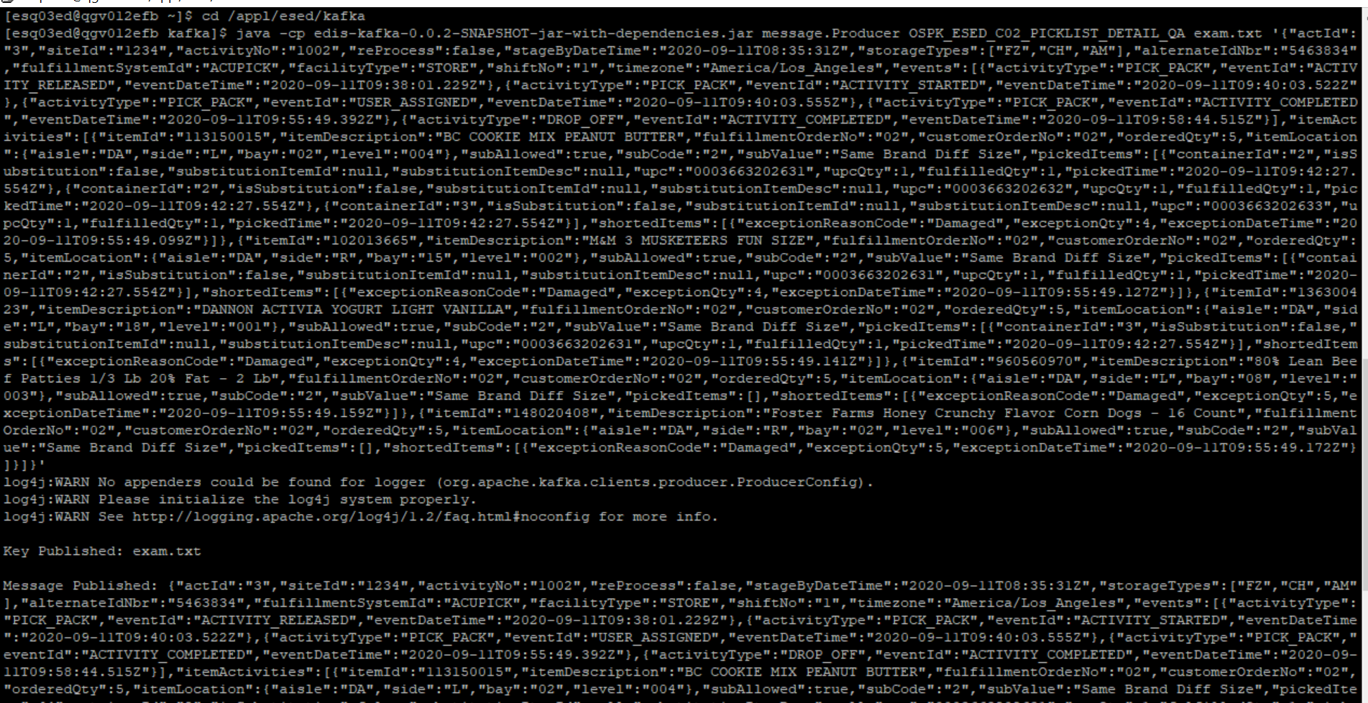

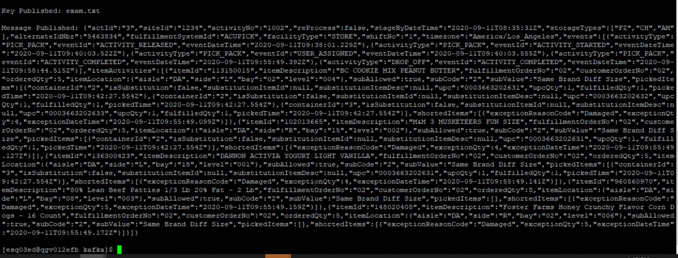

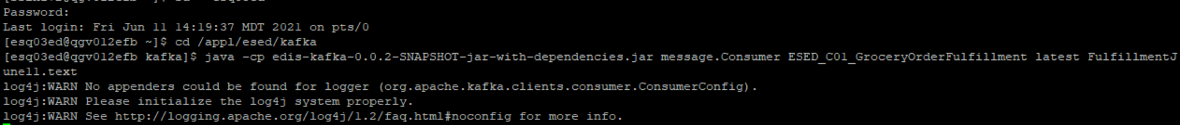

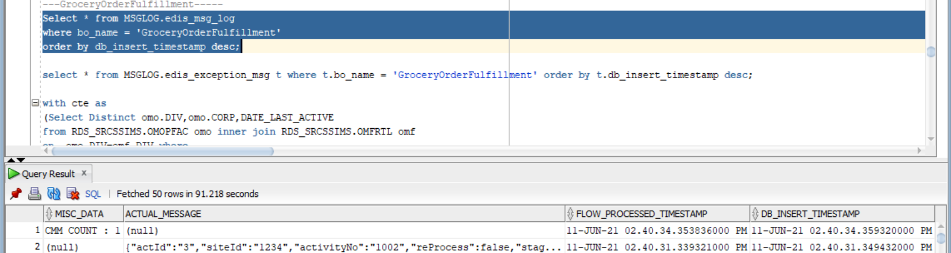

No Exception-

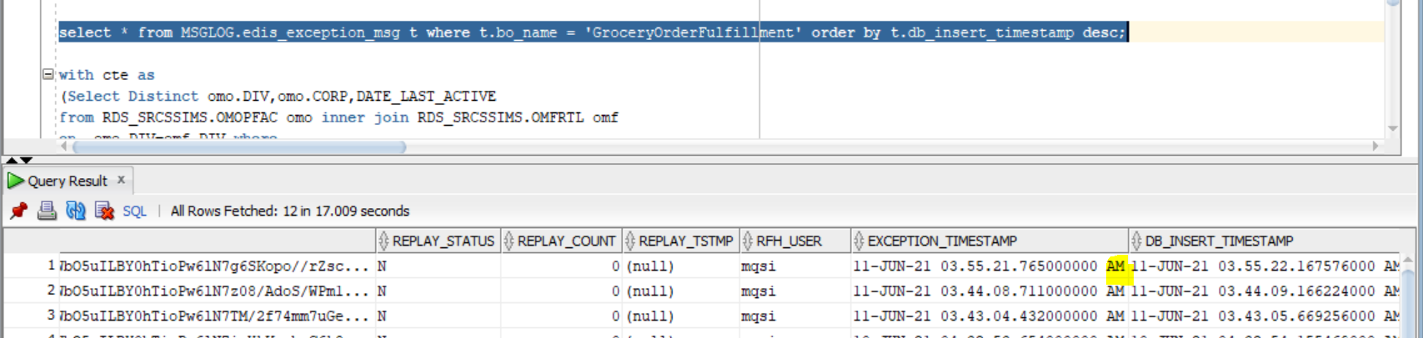

CMM xml-

<GetGroceryOrderFulfillment

xmlns:Abs="https://collab.safeway.com/it/architecture/info/default.aspx">

<DocumentData>

<Document ReleaseId="" VersionId="1.4.1.011" SystemEnvironmentCd="QA">

<Abs:DocumentID>ESED_C01_GroceryOrderFulfillment_2021-06-11T14:40:31.342-06:00</Abs:DocumentID>

<Abs:AlternateDocumentID>ESED_C01_GroceryOrderFulfillment_0_1329_2021-06-11T14:40:31.342-06:00</Abs:AlternateDocumentID>

<Abs:DocumentNm>GroceryOrderFulfillment</Abs:DocumentNm>

<Abs:CreationDt>2021-06-11T14:40:31.342-06:00</Abs:CreationDt>

<Abs:Description>GroceryOrderFulfillmentDetail</Abs:Description>

<Abs:SourceApplicationCd>AcuPick</Abs:SourceApplicationCd>

<Abs:TargetApplicationCd>EDIS</Abs:TargetApplicationCd>

<Abs:InternalFileTransferInd>Y</Abs:InternalFileTransferInd>

<Abs:DataClassification>

<Abs:DataClassificationLevel>

<Abs:Code>Internal</Abs:Code>

</Abs:DataClassificationLevel>

<Abs:BusinessSensitivityLevel>

<Abs:Code>Low</Abs:Code>

</Abs:BusinessSensitivityLevel>

<Abs:PHIdataInd>N</Abs:PHIdataInd>

<Abs:PCIdataInd>Y</Abs:PCIdataInd>

<Abs:PIIdataInd>Y</Abs:PIIdataInd>

</Abs:DataClassification>

</Document>

<DocumentAction>

<Abs:ActionTypeCd>UPDATE</Abs:ActionTypeCd>

<Abs:RecordTypeCd>CHANGE</Abs:RecordTypeCd>

</DocumentAction>

</DocumentData>

<GroceryOrderFulfillmentData>

<Abs:CorporationId>001</Abs:CorporationId>

<Abs:DivisionId>25</Abs:DivisionId>

<Abs:FacilityId>1234</Abs:FacilityId>

<Abs:FacilityType>

<Abs:Code>STORE</Abs:Code>

</Abs:FacilityType>

<Abs:OrderFulfillmentData>

<Abs:Assignment>

<Abs:AssignmentId>1002</Abs:AssignmentId>

<Abs:PicklistId>1002</Abs:PicklistId>

<Abs:FulfillmentSystemType>

<Abs:Code>ACUPICK</Abs:Code>

</Abs:FulfillmentSystemType>

<Abs:FacilityEmployee>

<Abs:EmployeeAltId>

<Abs:AlternateIdTxt>LwlKJnI</Abs:AlternateIdTxt>

</Abs:EmployeeAltId>

</Abs:FacilityEmployee>

<Abs:AssignmentStatus>

<Abs:StatusTypeCd>false</Abs:StatusTypeCd>

<Abs:Description>ReProcess</Abs:Description>

</Abs:AssignmentStatus>

<Abs:ScheduledStartTS>2020-09-11T08:35:31Z</Abs:ScheduledStartTS>

<Abs:ShiftNbr>1</Abs:ShiftNbr>

<Abs:StorageUnitData>

<Abs:ActivityStorageUnitType>

<Abs:StorageUnitSubType>

<Abs:Code>FZ</Abs:Code>

</Abs:StorageUnitSubType>

</Abs:ActivityStorageUnitType>

<Abs:ActivityStorageUnitType>

<Abs:StorageUnitSubType>

<Abs:Code>CH</Abs:Code>

</Abs:StorageUnitSubType>

</Abs:ActivityStorageUnitType>

<Abs:ActivityStorageUnitType>

<Abs:StorageUnitSubType>

<Abs:Code>AM</Abs:Code>

</Abs:StorageUnitSubType>

</Abs:ActivityStorageUnitType>

</Abs:StorageUnitData>

</Abs:Assignment>

<Abs:AssignmentEvent>

<Abs:AssignmentEventType>

<Abs:Code>PICK_PACK</Abs:Code>

</Abs:AssignmentEventType>

<Abs:AssignmentEventSubType>

<Abs:Code>ACTIVITY_RELEASED</Abs:Code>

</Abs:AssignmentEventSubType>

<Abs:EventStartTs>2020-09-11T09:38:01.229Z</Abs:EventStartTs>

</Abs:AssignmentEvent>

<Abs:AssignmentEvent>

<Abs:AssignmentEventType>

<Abs:Code>PICK_PACK</Abs:Code>

</Abs:AssignmentEventType>

<Abs:AssignmentEventSubType>

<Abs:Code>ACTIVITY_STARTED</Abs:Code>

</Abs:AssignmentEventSubType>

<Abs:EventStartTs>2020-09-11T09:40:03.522Z</Abs:EventStartTs>

</Abs:AssignmentEvent>

<Abs:AssignmentEvent>

<Abs:AssignmentEventType>

<Abs:Code>PICK_PACK</Abs:Code>

</Abs:AssignmentEventType>

<Abs:AssignmentEventSubType>

<Abs:Code>USER_ASSIGNED</Abs:Code>

</Abs:AssignmentEventSubType>

<Abs:EventStartTs>2020-09-11T09:40:03.555Z</Abs:EventStartTs>

</Abs:AssignmentEvent>

<Abs:AssignmentEvent>

<Abs:AssignmentEventType>

<Abs:Code>PICK_PACK</Abs:Code>

</Abs:AssignmentEventType>

<Abs:AssignmentEventSubType>

<Abs:Code>ACTIVITY_COMPLETED</Abs:Code>

</Abs:AssignmentEventSubType>

<Abs:EventStartTs>2020-09-11T09:55:49.392Z</Abs:EventStartTs>

<Abs:ItemSelection>

<Abs:PickListId>1002</Abs:PickListId>

<Abs:FulfillmentOrderId>02</Abs:FulfillmentOrderId>

<Abs:OrderId>02</Abs:OrderId>

<Abs:OrderedItem>

<Abs:BaseProductNbr>113150015</Abs:BaseProductNbr>

<Abs:ItemDescription>BC COOKIE MIX PEANUT BUTTER</Abs:ItemDescription>

</Abs:OrderedItem>

<Abs:SubstitutionAllowedInd>true</Abs:SubstitutionAllowedInd>

<Abs:SubstitutionType>

<Abs:Code>2</Abs:Code>

<Abs:Description>Same Brand Diff Size</Abs:Description>

</Abs:SubstitutionType>

<Abs:FulfilledItem>

<Abs:UPC>

<Abs:UPCNbr>3663202633</Abs:UPCNbr>

<Abs:UPCTxt>0003663202633</Abs:UPCTxt>

</Abs:UPC>

<Abs:SubstituteItemInd>false</Abs:SubstituteItemInd>

<Abs:StorageUnitId>3</Abs:StorageUnitId>

</Abs:FulfilledItem>

<Abs:ItemQty>1.0000</Abs:ItemQty>

<Abs:ScheduledStartTs>2020-09-11T09:42:27.554Z</Abs:ScheduledStartTs>

<Abs:OrderQty>5.0000</Abs:OrderQty>

<Abs:SelectionLocation>

<Abs:LocationType>

<Abs:Code>DA</Abs:Code>

<Abs:Name>aisle</Abs:Name>

</Abs:LocationType>

<Abs:LocationType>

<Abs:Code>L</Abs:Code>

<Abs:Name>side</Abs:Name>

</Abs:LocationType>

<Abs:LocationType>

<Abs:Code>02</Abs:Code>

<Abs:Name>bay</Abs:Name>

</Abs:LocationType>

<Abs:LocationType>

<Abs:Code>004</Abs:Code>

<Abs:Name>level</Abs:Name>

</Abs:LocationType>

</Abs:SelectionLocation>

<Abs:OrderLineExceptions>

<Abs:ExceptionReasonType>

<Abs:Code>Damaged</Abs:Code>

</Abs:ExceptionReasonType>

<Abs:ExceptionItemQty>4.0000</Abs:ExceptionItemQty>

<Abs:ExceptionCreateTs>2020-09-11T09:55:49.099Z</Abs:ExceptionCreateTs>

</Abs:OrderLineExceptions>

</Abs:ItemSelection>

<Abs:ItemSelection>

<Abs:PickListId>1002</Abs:PickListId>

<Abs:FulfillmentOrderId>02</Abs:FulfillmentOrderId>

<Abs:OrderId>02</Abs:OrderId>

<Abs:OrderedItem>

<Abs:BaseProductNbr>102013665</Abs:BaseProductNbr>

<Abs:ItemDescription>M&amp;M 3 MUSKETEERS FUN SIZE</Abs:ItemDescription>

</Abs:OrderedItem>

<Abs:SubstitutionAllowedInd>true</Abs:SubstitutionAllowedInd>

<Abs:SubstitutionType>

<Abs:Code>2</Abs:Code>

<Abs:Description>Same Brand Diff Size</Abs:Description>

</Abs:SubstitutionType>

<Abs:FulfilledItem>

<Abs:UPC>

<Abs:UPCNbr>3663202631</Abs:UPCNbr>

<Abs:UPCTxt>0003663202631</Abs:UPCTxt>

</Abs:UPC>

<Abs:SubstituteItemInd>false</Abs:SubstituteItemInd>

<Abs:StorageUnitId>2</Abs:StorageUnitId>

</Abs:FulfilledItem>

<Abs:ItemQty>1.0000</Abs:ItemQty>

<Abs:ScheduledStartTs>2020-09-11T09:42:27.554Z</Abs:ScheduledStartTs>

<Abs:OrderQty>5.0000</Abs:OrderQty>

<Abs:SelectionLocation>

<Abs:LocationType>

<Abs:Code>DA</Abs:Code>

<Abs:Name>aisle</Abs:Name>

</Abs:LocationType>

<Abs:LocationType>

<Abs:Code>R</Abs:Code>

<Abs:Name>side</Abs:Name>

</Abs:LocationType>

<Abs:LocationType>

<Abs:Code>15</Abs:Code>

<Abs:Name>bay</Abs:Name>

</Abs:LocationType>

<Abs:LocationType>

<Abs:Code>002</Abs:Code>

<Abs:Name>level</Abs:Name>

</Abs:LocationType>

</Abs:SelectionLocation>

<Abs:OrderLineExceptions>

<Abs:ExceptionReasonType>

<Abs:Code>Damaged</Abs:Code>

</Abs:ExceptionReasonType>

<Abs:ExceptionItemQty>4.0000</Abs:ExceptionItemQty>

<Abs:ExceptionCreateTs>2020-09-11T09:55:49.127Z</Abs:ExceptionCreateTs>

</Abs:OrderLineExceptions>

</Abs:ItemSelection>

<Abs:ItemSelection>

<Abs:PickListId>1002</Abs:PickListId>

<Abs:FulfillmentOrderId>02</Abs:FulfillmentOrderId>

<Abs:OrderId>02</Abs:OrderId>

<Abs:OrderedItem>

<Abs:BaseProductNbr>136300423</Abs:BaseProductNbr>

<Abs:ItemDescription>DANNON ACTIVIA YOGURT LIGHT VANILLA</Abs:ItemDescription>

</Abs:OrderedItem>

<Abs:SubstitutionAllowedInd>true</Abs:SubstitutionAllowedInd>

<Abs:SubstitutionType>

<Abs:Code>2</Abs:Code>

<Abs:Description>Same Brand Diff Size</Abs:Description>

</Abs:SubstitutionType>

<Abs:FulfilledItem>

<Abs:UPC>

<Abs:UPCNbr>3663202631</Abs:UPCNbr>

<Abs:UPCTxt>0003663202631</Abs:UPCTxt>

</Abs:UPC>

<Abs:SubstituteItemInd>false</Abs:SubstituteItemInd>

<Abs:StorageUnitId>3</Abs:StorageUnitId>

</Abs:FulfilledItem>

<Abs:ItemQty>1.0000</Abs:ItemQty>

<Abs:ScheduledStartTs>2020-09-11T09:42:27.554Z</Abs:ScheduledStartTs>

<Abs:OrderQty>5.0000</Abs:OrderQty>

<Abs:SelectionLocation>

<Abs:LocationType>

<Abs:Code>DA</Abs:Code>

<Abs:Name>aisle</Abs:Name>

</Abs:LocationType>

<Abs:LocationType>

<Abs:Code>L</Abs:Code>

<Abs:Name>side</Abs:Name>

</Abs:LocationType>

<Abs:LocationType>

<Abs:Code>18</Abs:Code>

<Abs:Name>bay</Abs:Name>

</Abs:LocationType>

<Abs:LocationType>

<Abs:Code>001</Abs:Code>

<Abs:Name>level</Abs:Name>

</Abs:LocationType>

</Abs:SelectionLocation>

<Abs:OrderLineExceptions>

<Abs:ExceptionReasonType>

<Abs:Code>Damaged</Abs:Code>

</Abs:ExceptionReasonType>

<Abs:ExceptionItemQty>4.0000</Abs:ExceptionItemQty>

<Abs:ExceptionCreateTs>2020-09-11T09:55:49.141Z</Abs:ExceptionCreateTs>

</Abs:OrderLineExceptions>

</Abs:ItemSelection>

<Abs:ItemSelection>

<Abs:PickListId>1002</Abs:PickListId>

<Abs:FulfillmentOrderId>02</Abs:FulfillmentOrderId>

<Abs:OrderId>02</Abs:OrderId>

<Abs:OrderedItem>

<Abs:BaseProductNbr>960560970</Abs:BaseProductNbr>

<Abs:ItemDescription>80% Lean Beef Patties 1/3 Lb 20% Fat - 2 Lb</Abs:ItemDescription>

</Abs:OrderedItem>

<Abs:SubstitutionAllowedInd>true</Abs:SubstitutionAllowedInd>

<Abs:SubstitutionType>

<Abs:Code>2</Abs:Code>

<Abs:Description>Same Brand Diff Size</Abs:Description>

</Abs:SubstitutionType>

<Abs:OrderQty>5.0000</Abs:OrderQty>

<Abs:SelectionLocation>

<Abs:LocationType>

<Abs:Code>DA</Abs:Code>

<Abs:Name>aisle</Abs:Name>

</Abs:LocationType>

<Abs:LocationType>

<Abs:Code>L</Abs:Code>

<Abs:Name>side</Abs:Name>

</Abs:LocationType>

<Abs:LocationType>

<Abs:Code>08</Abs:Code>

<Abs:Name>bay</Abs:Name>

</Abs:LocationType>

<Abs:LocationType>

<Abs:Code>003</Abs:Code>

<Abs:Name>level</Abs:Name>

</Abs:LocationType>

</Abs:SelectionLocation>

<Abs:OrderLineExceptions>

<Abs:ExceptionReasonType>

<Abs:Code>Damaged</Abs:Code>

</Abs:ExceptionReasonType>

<Abs:ExceptionItemQty>5.0000</Abs:ExceptionItemQty>

<Abs:ExceptionCreateTs>2020-09-11T09:55:49.159Z</Abs:ExceptionCreateTs>

</Abs:OrderLineExceptions>

</Abs:ItemSelection>

<Abs:ItemSelection>

<Abs:PickListId>1002</Abs:PickListId>

<Abs:FulfillmentOrderId>02</Abs:FulfillmentOrderId>

<Abs:OrderId>02</Abs:OrderId>

<Abs:OrderedItem>

<Abs:BaseProductNbr>148020408</Abs:BaseProductNbr>

<Abs:ItemDescription>Foster Farms Honey Crunchy Flavor Corn Dogs - 16 Count</Abs:ItemDescription>

</Abs:OrderedItem>

<Abs:SubstitutionAllowedInd>true</Abs:SubstitutionAllowedInd>

<Abs:SubstitutionType>

<Abs:Code>2</Abs:Code>

<Abs:Description>Same Brand Diff Size</Abs:Description>

</Abs:SubstitutionType>

<Abs:OrderQty>5.0000</Abs:OrderQty>

<Abs:SelectionLocation>

<Abs:LocationType>

<Abs:Code>DA</Abs:Code>

<Abs:Name>aisle</Abs:Name>

</Abs:LocationType>

<Abs:LocationType>

<Abs:Code>R</Abs:Code>

<Abs:Name>side</Abs:Name>

</Abs:LocationType>

<Abs:LocationType>

<Abs:Code>02</Abs:Code>

<Abs:Name>bay</Abs:Name>

</Abs:LocationType>

<Abs:LocationType>

<Abs:Code>006</Abs:Code>

<Abs:Name>level</Abs:Name>

</Abs:LocationType>

</Abs:SelectionLocation>

<Abs:OrderLineExceptions>

<Abs:ExceptionReasonType>

<Abs:Code>Damaged</Abs:Code>

</Abs:ExceptionReasonType>

<Abs:ExceptionItemQty>5.0000</Abs:ExceptionItemQty>

<Abs:ExceptionCreateTs>2020-09-11T09:55:49.172Z</Abs:ExceptionCreateTs>

</Abs:OrderLineExceptions>

</Abs:ItemSelection>

</Abs:AssignmentEvent>

<Abs:AssignmentEvent>

<Abs:AssignmentEventType>

<Abs:Code>DROP_OFF</Abs:Code>

</Abs:AssignmentEventType>

<Abs:AssignmentEventSubType>

<Abs:Code>ACTIVITY_COMPLETED</Abs:Code>

</Abs:AssignmentEventSubType>

<Abs:EventStartTs>2020-09-11T09:58:44.515Z</Abs:EventStartTs>

</Abs:AssignmentEvent>

</Abs:OrderFulfillmentData>

</GroceryOrderFulfillmentData>

</GetGroceryOrderFulfillment>

Scenario_2 Validate CMM xml with mapping version 1.4.1

{"actId":"11351","siteId":"2053","activityNo":"1003","reProcess":false,"stageByDateTime":"2021-06-11T22:30:00Z","storageTypes":["AM"],"alternateIdNbr":"rqZVvQO","fulfillmentSystemId":"ACUPICK","facilityType":"STORE","shiftNo":"2","timezone":"America/Los_Angeles","events":[{"activityType":"PICK_PACK","eventId":"ACTIVITY_CREATED","eventDateTime":"2021-06-11T19:18:29.595Z"},{"activityType":"PICK_PACK","eventId":"ACTIVITY_RELEASED","eventDateTime":"2021-06-11T19:18:29.597Z"},{"activityType":"PICK_PACK","eventId":"ACTIVITY_STARTED","eventDateTime":"2021-06-11T19:20:10.968Z"},{"activityType":"PICK_PACK","eventId":"USER_ASSIGNED","eventDateTime":"2021-06-11T19:20:10.973Z"},{"activityType":"PICK_PACK","eventId":"ACTIVITY_COMPLETED","eventDateTime":"2021-06-11T19:21:19.016Z"},{"activityType":"PICK_PACK","eventId":"BAGGING_EVENT","eventDateTime":"2021-06-11T19:21:23.252Z"},{"activityType":"DROP_OFF","eventId":"ACTIVITY_CREATED","eventDateTime":"2021-06-11T19:21:18.996Z"},{"activityType":"DROP_OFF","eventId":"ACTIVITY_COMPLETED","eventDateTime":"2021-06-11T19:21:39.672Z"}],"itemActivities":[{"itemId":"189051131","itemDescription":"Kendall-Jackson Grand Reserve Wine White Chardonnay - 750 Ml","fulfillmentOrderNo":"20112551011","customerOrderNo":"20112551","orderedQty":2,"itemLocation":{"aisle":"002","side":"112","bay":"12","level":"020"},"subAllowed":true,"subCode":"3","subValue":"Best Available","substituteItem":[{"itemId":"189051131","itemDescription":"Test1Test2","rank":1}],"pickedItems":[{"containerId":"TTB33","isSubstitution":false,"isSmartSubItem":false,"subReasonCode":"TestOffer1","substitutionItemId":null,"substitutionItemDesc":null,"upc":"081584013082","upcQty":2,"fulfilledQty":2,"pickedTime":"2021-06-11T19:21:17.406Z","sellByWeightInd":"I"}],"shortedItems":[]}]}

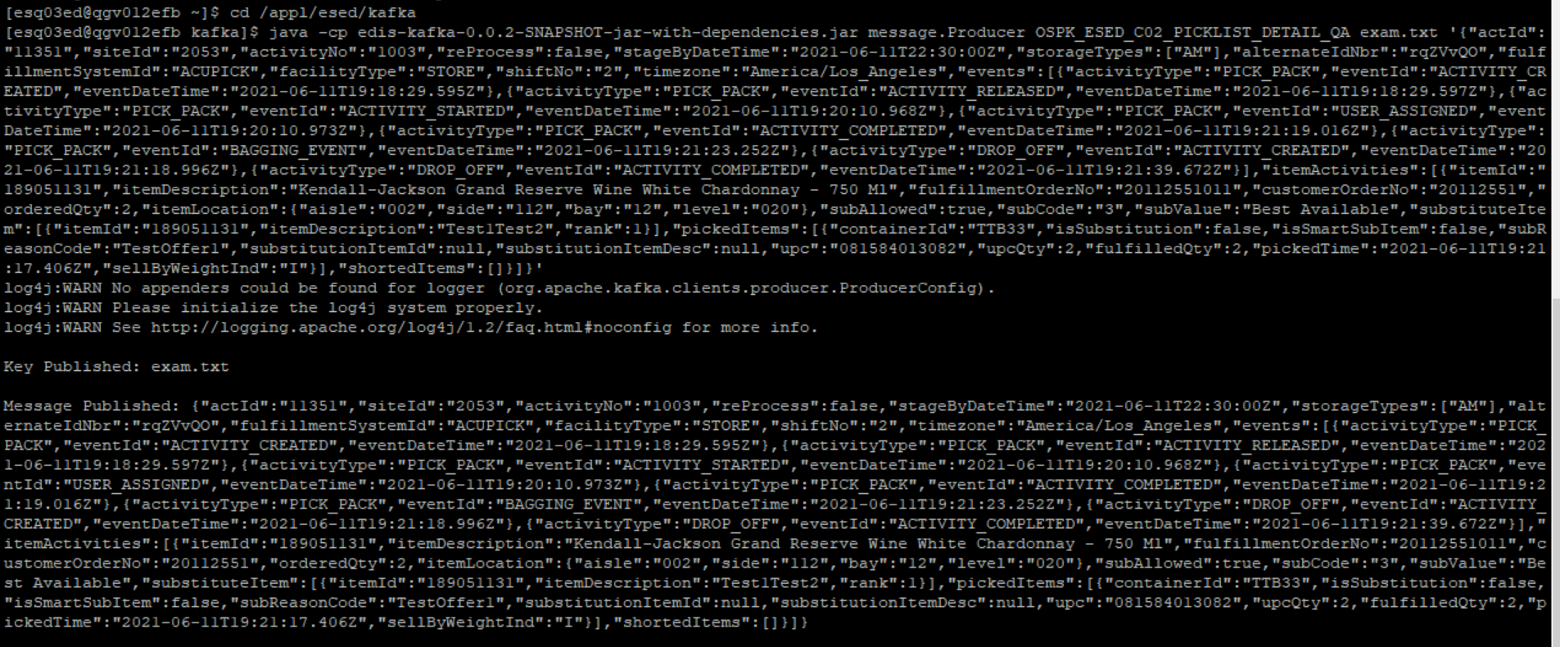

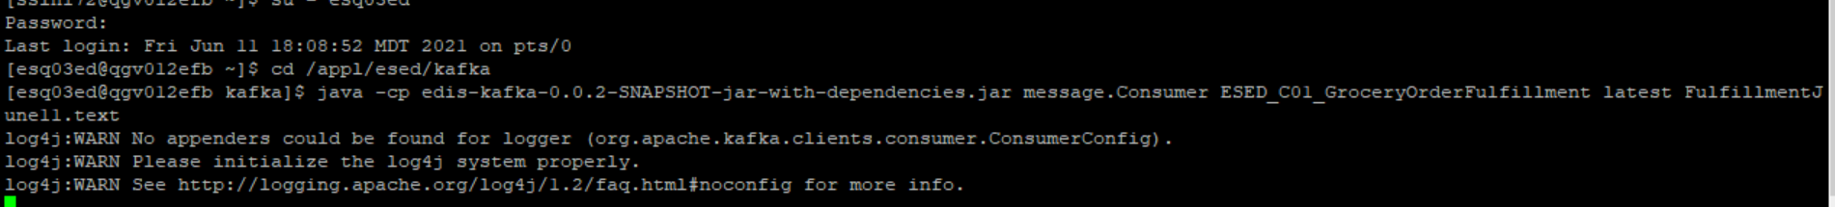

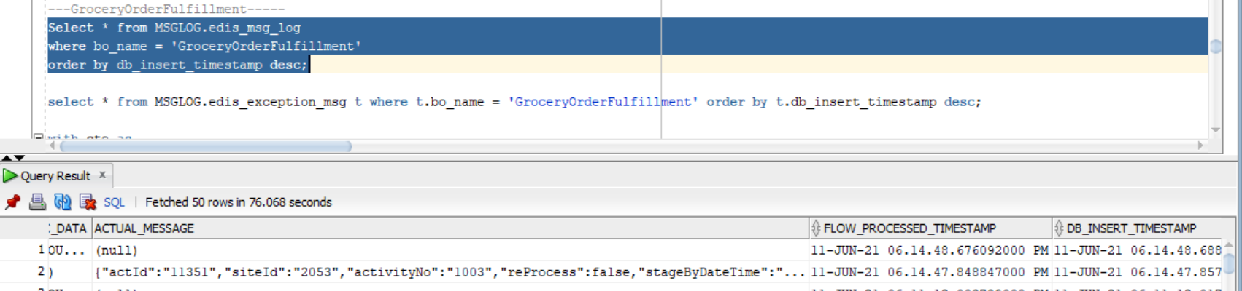

No Exception

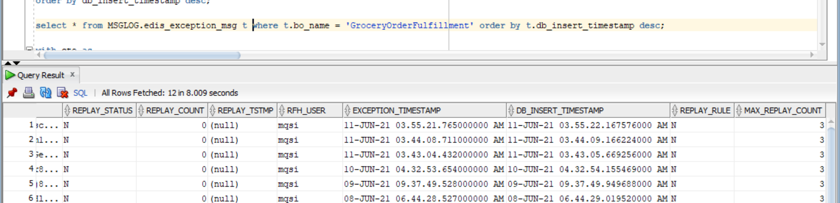

CMM XML-

<GetGroceryOrderFulfillment

xmlns:Abs="https://collab.safeway.com/it/architecture/info/default.aspx">

<DocumentData>

<Document ReleaseId="" VersionId="1.4.1.011" SystemEnvironmentCd="QA">

<Abs:DocumentID>ESED_C01_GroceryOrderFulfillment_2021-06-11T18:14:47.850-06:00</Abs:DocumentID>

<Abs:AlternateDocumentID>ESED_C01_GroceryOrderFulfillment_0_1334_2021-06-11T18:14:47.850-06:00</Abs:AlternateDocumentID>

<Abs:DocumentNm>GroceryOrderFulfillment</Abs:DocumentNm>

<Abs:CreationDt>2021-06-11T18:14:47.850-06:00</Abs:CreationDt>

<Abs:Description>GroceryOrderFulfillmentDetail</Abs:Description>

<Abs:SourceApplicationCd>AcuPick</Abs:SourceApplicationCd>

<Abs:TargetApplicationCd>EDIS</Abs:TargetApplicationCd>

<Abs:InternalFileTransferInd>Y</Abs:InternalFileTransferInd>

<Abs:DataClassification>

<Abs:DataClassificationLevel>

<Abs:Code>Internal</Abs:Code>

</Abs:DataClassificationLevel>

<Abs:BusinessSensitivityLevel>

<Abs:Code>Low</Abs:Code>

</Abs:BusinessSensitivityLevel>

<Abs:PHIdataInd>N</Abs:PHIdataInd>

<Abs:PCIdataInd>Y</Abs:PCIdataInd>

<Abs:PIIdataInd>Y</Abs:PIIdataInd>

</Abs:DataClassification>

</Document>

<DocumentAction>

<Abs:ActionTypeCd>UPDATE</Abs:ActionTypeCd>

<Abs:RecordTypeCd>CHANGE</Abs:RecordTypeCd>

</DocumentAction>

</DocumentData>

<GroceryOrderFulfillmentData>

<Abs:CorporationId>001</Abs:CorporationId>

<Abs:DivisionId>29</Abs:DivisionId>

<Abs:FacilityId>2053</Abs:FacilityId>

<Abs:FacilityType>

<Abs:Code>STORE</Abs:Code>

</Abs:FacilityType>

<Abs:OrderFulfillmentData>

<Abs:Assignment>

<Abs:AssignmentId>1003</Abs:AssignmentId>

<Abs:PicklistId>1003</Abs:PicklistId>

<Abs:FulfillmentSystemType>

<Abs:Code>ACUPICK</Abs:Code>

</Abs:FulfillmentSystemType>

<Abs:FacilityEmployee>

<Abs:EmployeeAltId>

<Abs:AlternateIdTxt>konqDwt</Abs:AlternateIdTxt>

</Abs:EmployeeAltId>

</Abs:FacilityEmployee>

<Abs:AssignmentStatus>

<Abs:StatusTypeCd>false</Abs:StatusTypeCd>

<Abs:Description>ReProcess</Abs:Description>

</Abs:AssignmentStatus>

<Abs:ScheduledStartTS>2021-06-11T22:30:00Z</Abs:ScheduledStartTS>

<Abs:ShiftNbr>2</Abs:ShiftNbr>

<Abs:StorageUnitData>

<Abs:ActivityStorageUnitType>

<Abs:StorageUnitSubType>

<Abs:Code>AM</Abs:Code>

</Abs:StorageUnitSubType>

</Abs:ActivityStorageUnitType>

</Abs:StorageUnitData>

</Abs:Assignment>

<Abs:AssignmentEvent>

<Abs:AssignmentEventType>

<Abs:Code>PICK_PACK</Abs:Code>

</Abs:AssignmentEventType>

<Abs:AssignmentEventSubType>

<Abs:Code>ACTIVITY_CREATED</Abs:Code>

</Abs:AssignmentEventSubType>

<Abs:EventStartTs>2021-06-11T19:18:29.595Z</Abs:EventStartTs>

</Abs:AssignmentEvent>

<Abs:AssignmentEvent>

<Abs:AssignmentEventType>

<Abs:Code>PICK_PACK</Abs:Code>

</Abs:AssignmentEventType>

<Abs:AssignmentEventSubType>

<Abs:Code>ACTIVITY_RELEASED</Abs:Code>

</Abs:AssignmentEventSubType>

<Abs:EventStartTs>2021-06-11T19:18:29.597Z</Abs:EventStartTs>

</Abs:AssignmentEvent>

<Abs:AssignmentEvent>

<Abs:AssignmentEventType>

<Abs:Code>PICK_PACK</Abs:Code>

</Abs:AssignmentEventType>

<Abs:AssignmentEventSubType>

<Abs:Code>ACTIVITY_STARTED</Abs:Code>

</Abs:AssignmentEventSubType>

<Abs:EventStartTs>2021-06-11T19:20:10.968Z</Abs:EventStartTs>

</Abs:AssignmentEvent>

<Abs:AssignmentEvent>

<Abs:AssignmentEventType>

<Abs:Code>PICK_PACK</Abs:Code>

</Abs:AssignmentEventType>

<Abs:AssignmentEventSubType>

<Abs:Code>USER_ASSIGNED</Abs:Code>

</Abs:AssignmentEventSubType>

<Abs:EventStartTs>2021-06-11T19:20:10.973Z</Abs:EventStartTs>

</Abs:AssignmentEvent>

<Abs:AssignmentEvent>

<Abs:AssignmentEventType>

<Abs:Code>PICK_PACK</Abs:Code>

</Abs:AssignmentEventType>

<Abs:AssignmentEventSubType>

<Abs:Code>ACTIVITY_COMPLETED</Abs:Code>

</Abs:AssignmentEventSubType>

<Abs:EventStartTs>2021-06-11T19:21:19.016Z</Abs:EventStartTs>

<Abs:ItemSelection>

<Abs:PickListId>1003</Abs:PickListId>

<Abs:FulfillmentOrderId>20112551011</Abs:FulfillmentOrderId>

<Abs:OrderId>20112551</Abs:OrderId>

<Abs:OrderedItem>

<Abs:BaseProductNbr>189051131</Abs:BaseProductNbr>

<Abs:ItemDescription>Kendall-Jackson Grand Reserve Wine White Chardonnay - 750 Ml</Abs:ItemDescription>

</Abs:OrderedItem>

<Abs:SubstitutionAllowedInd>true</Abs:SubstitutionAllowedInd>

<Abs:SubstitutionType>

<Abs:Code>3</Abs:Code>

<Abs:Description>Best Available</Abs:Description>

</Abs:SubstitutionType>

<Abs:SubstituteItem>

<Abs:SystemSpecificItemId>189051131</Abs:SystemSpecificItemId>

<Abs:ItemDescription>Test1Test2</Abs:ItemDescription>

<Abs:SubstituteItemRankNbr>1</Abs:SubstituteItemRankNbr>

</Abs:SubstituteItem>

<Abs:FulfilledItem>

<Abs:UPC>

<Abs:UPCNbr>81584013082</Abs:UPCNbr>

<Abs:UPCTxt>081584013082</Abs:UPCTxt>

</Abs:UPC>

<Abs:SubstituteItemInd>false</Abs:SubstituteItemInd>

<Abs:SmartSubstituteItemInd>false</Abs:SmartSubstituteItemInd>

<Abs:SubstituteItemReasonCd>TestOffer1</Abs:SubstituteItemReasonCd>

<Abs:StorageUnitId>TTB33</Abs:StorageUnitId>

</Abs:FulfilledItem>

<Abs:ItemQty>2.0000</Abs:ItemQty>

<Abs:ScheduledStartTs>2021-06-11T19:21:17.406Z</Abs:ScheduledStartTs>

<Abs:OrderQty>2.0000</Abs:OrderQty>

<Abs:SelectionLocation>

<Abs:LocationType>

<Abs:Code>002</Abs:Code>

<Abs:Name>aisle</Abs:Name>

</Abs:LocationType>

<Abs:LocationType>

<Abs:Code>112</Abs:Code>

<Abs:Name>side</Abs:Name>

</Abs:LocationType>

<Abs:LocationType>

<Abs:Code>12</Abs:Code>

<Abs:Name>bay</Abs:Name>

</Abs:LocationType>

<Abs:LocationType>

<Abs:Code>020</Abs:Code>

<Abs:Name>level</Abs:Name>

</Abs:LocationType>

</Abs:SelectionLocation>

</Abs:ItemSelection>

</Abs:AssignmentEvent>

<Abs:AssignmentEvent>

<Abs:AssignmentEventType>

<Abs:Code>PICK_PACK</Abs:Code>

</Abs:AssignmentEventType>

<Abs:AssignmentEventSubType>

<Abs:Code>BAGGING_EVENT</Abs:Code>

</Abs:AssignmentEventSubType>

<Abs:EventStartTs>2021-06-11T19:21:23.252Z</Abs:EventStartTs>

</Abs:AssignmentEvent>

<Abs:AssignmentEvent>

<Abs:AssignmentEventType>

<Abs:Code>DROP_OFF</Abs:Code>

</Abs:AssignmentEventType>

<Abs:AssignmentEventSubType>

<Abs:Code>ACTIVITY_CREATED</Abs:Code>

</Abs:AssignmentEventSubType>

<Abs:EventStartTs>2021-06-11T19:21:18.996Z</Abs:EventStartTs>

</Abs:AssignmentEvent>

<Abs:AssignmentEvent>

<Abs:AssignmentEventType>

<Abs:Code>DROP_OFF</Abs:Code>

</Abs:AssignmentEventType>

<Abs:AssignmentEventSubType>

<Abs:Code>ACTIVITY_COMPLETED</Abs:Code>

</Abs:AssignmentEventSubType>

<Abs:EventStartTs>2021-06-11T19:21:39.672Z</Abs:EventStartTs>

</Abs:AssignmentEvent>

</Abs:OrderFulfillmentData>

</GroceryOrderFulfillmentData>

</GetGroceryOrderFulfillment>

Scenario-3

JSON message-

{"actId":"11351","siteId":"2053","activityNo":"1004","reProcess":false,"stageByDateTime":"2021-06-11T22:30:00Z","storageTypes":["AM"],"alternateIdNbr":"rqZVvQO","fulfillmentSystemId":"ACUPICK","facilityType":"STORE","shiftNo":"2","timezone":"America/Los_Angeles","events":[{"activityType":"PICK_PACK","eventId":"ACTIVITY_CREATED","eventDateTime":"2021-06-11T19:18:29.595Z"},{"activityType":"PICK_PACK","eventId":"ACTIVITY_RELEASED","eventDateTime":"2021-06-11T19:18:29.597Z"},{"activityType":"PICK_PACK","eventId":"ACTIVITY_STARTED","eventDateTime":"2021-06-11T19:20:10.968Z"},{"activityType":"PICK_PACK","eventId":"USER_ASSIGNED","eventDateTime":"2021-06-11T19:20:10.973Z"},{"activityType":"PICK_PACK","eventId":"ACTIVITY_COMPLETED","eventDateTime":"2021-06-11T19:21:19.016Z"},{"activityType":"PICK_PACK","eventId":"BAGGING_EVENT","eventDateTime":"2021-06-11T19:21:23.252Z"},{"activityType":"DROP_OFF","eventId":"ACTIVITY_CREATED","eventDateTime":"2021-06-11T19:21:18.996Z"},{"activityType":"DROP_OFF","eventId":"ACTIVITY_COMPLETED","eventDateTime":"2021-06-11T19:21:39.672Z"}],"itemActivities":[{"itemId":"189051131","itemDescription":"Kendall-Jackson Grand Reserve Wine White Chardonnay - 750 Ml","fulfillmentOrderNo":"20112551011","customerOrderNo":"20112551","orderedQty":2,"itemLocation":{"aisle":"002","side":"112","bay":"12","level":"020"},"subAllowed":true,"subCode":"3","subValue":"Best Available","substituteItem":[{"itemId":"189051132","itemDescription":"Test1Test3","rank":1}],"pickedItems":[{"containerId":"TTB33","isSubstitution":true,"isSmartSubItem":true,"subReasonCode":"TestOffer2","substitutionItemId":null,"substitutionItemDesc":null,"upc":"081584013082","upcQty":2,"fulfilledQty":2,"pickedTime":"2021-06-11T19:21:17.406Z","sellByWeightInd":"I"}],"shortedItems":[]}]}

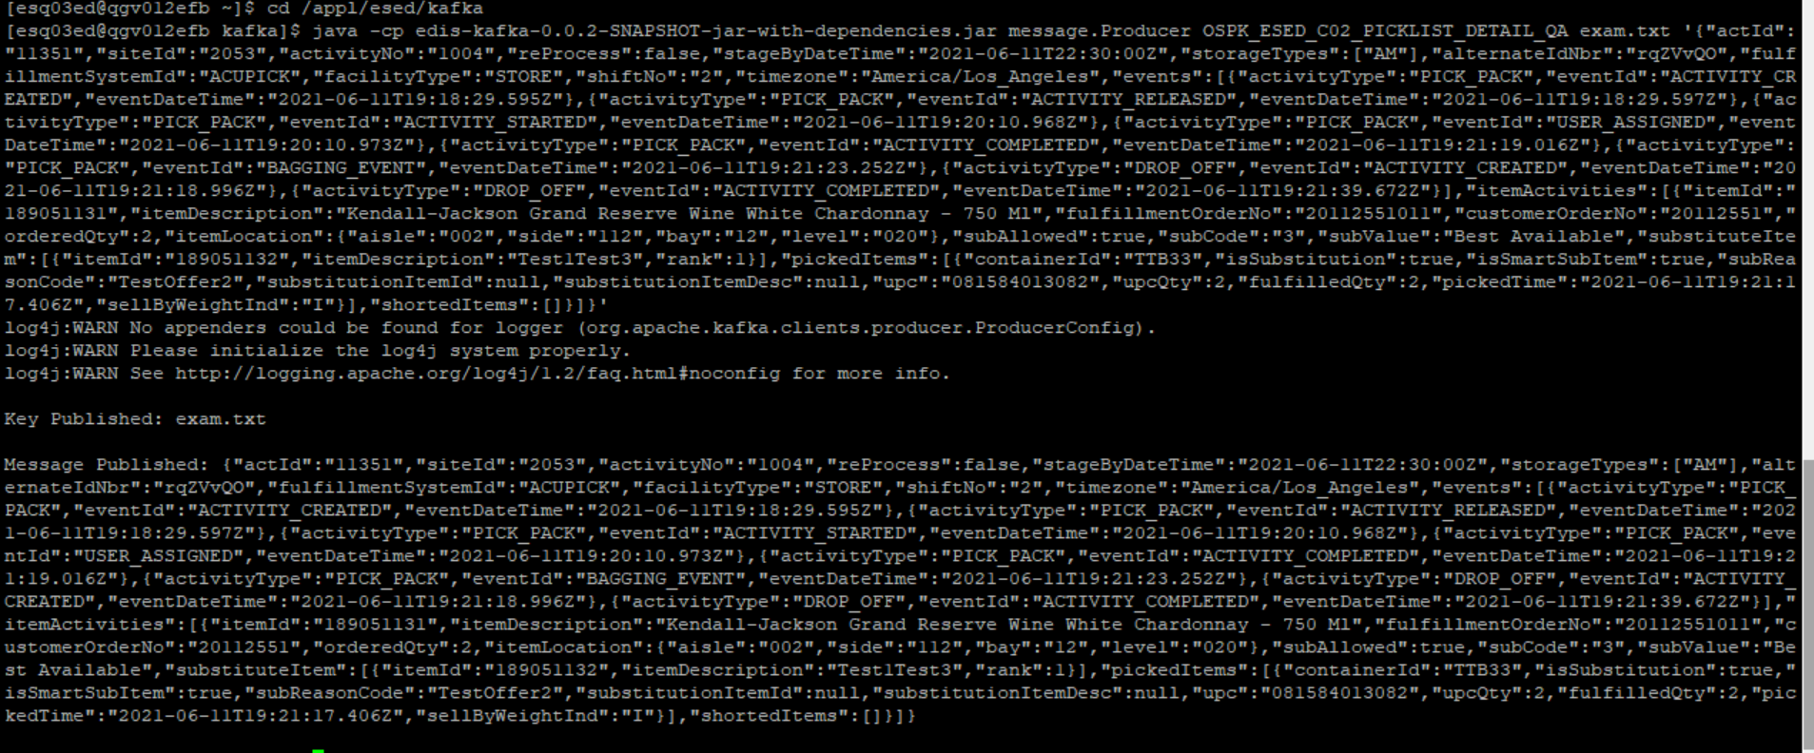

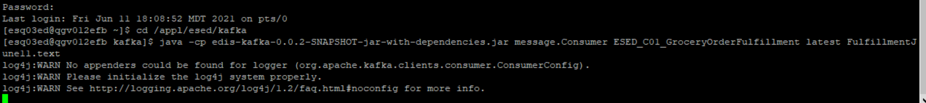

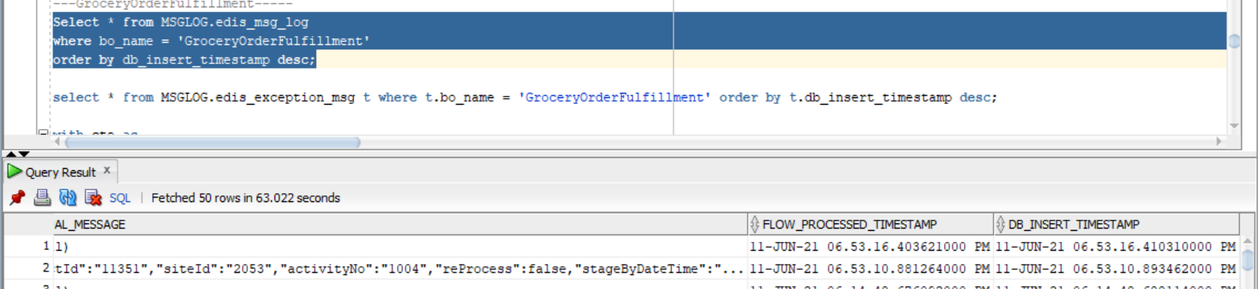

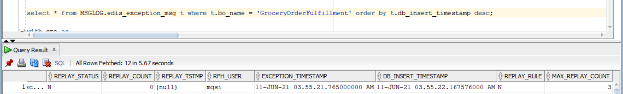

CMM xml-

<GetGroceryOrderFulfillment

xmlns:Abs="https://collab.safeway.com/it/architecture/info/default.aspx">

<DocumentData>

<Document ReleaseId="" VersionId="1.4.1.011" SystemEnvironmentCd="QA">

<Abs:DocumentID>ESED_C01_GroceryOrderFulfillment_2021-06-11T18:53:10.883-06:00</Abs:DocumentID>

<Abs:AlternateDocumentID>ESED_C01_GroceryOrderFulfillment_0_1335_2021-06-11T18:53:10.883-06:00</Abs:AlternateDocumentID>

<Abs:DocumentNm>GroceryOrderFulfillment</Abs:DocumentNm>

<Abs:CreationDt>2021-06-11T18:53:10.883-06:00</Abs:CreationDt>

<Abs:Description>GroceryOrderFulfillmentDetail</Abs:Description>

<Abs:SourceApplicationCd>AcuPick</Abs:SourceApplicationCd>

<Abs:TargetApplicationCd>EDIS</Abs:TargetApplicationCd>

<Abs:InternalFileTransferInd>Y</Abs:InternalFileTransferInd>

<Abs:DataClassification>

<Abs:DataClassificationLevel>

<Abs:Code>Internal</Abs:Code>

</Abs:DataClassificationLevel>

<Abs:BusinessSensitivityLevel>

<Abs:Code>Low</Abs:Code>

</Abs:BusinessSensitivityLevel>

<Abs:PHIdataInd>N</Abs:PHIdataInd>

<Abs:PCIdataInd>Y</Abs:PCIdataInd>

<Abs:PIIdataInd>Y</Abs:PIIdataInd>

</Abs:DataClassification>

</Document>

<DocumentAction>

<Abs:ActionTypeCd>UPDATE</Abs:ActionTypeCd>

<Abs:RecordTypeCd>CHANGE</Abs:RecordTypeCd>

</DocumentAction>

</DocumentData>

<GroceryOrderFulfillmentData>

<Abs:CorporationId>001</Abs:CorporationId>

<Abs:DivisionId>29</Abs:DivisionId>

<Abs:FacilityId>2053</Abs:FacilityId>

<Abs:FacilityType>

<Abs:Code>STORE</Abs:Code>

</Abs:FacilityType>

<Abs:OrderFulfillmentData>

<Abs:Assignment>

<Abs:AssignmentId>1004</Abs:AssignmentId>

<Abs:PicklistId>1004</Abs:PicklistId>

<Abs:FulfillmentSystemType>

<Abs:Code>ACUPICK</Abs:Code>

</Abs:FulfillmentSystemType>

<Abs:FacilityEmployee>

<Abs:EmployeeAltId>

<Abs:AlternateIdTxt>konqDwt</Abs:AlternateIdTxt>

</Abs:EmployeeAltId>

</Abs:FacilityEmployee>

<Abs:AssignmentStatus>

<Abs:StatusTypeCd>false</Abs:StatusTypeCd>

<Abs:Description>ReProcess</Abs:Description>

</Abs:AssignmentStatus>

<Abs:ScheduledStartTS>2021-06-11T22:30:00Z</Abs:ScheduledStartTS>

<Abs:ShiftNbr>2</Abs:ShiftNbr>

<Abs:StorageUnitData>

<Abs:ActivityStorageUnitType>

<Abs:StorageUnitSubType>

<Abs:Code>AM</Abs:Code>

</Abs:StorageUnitSubType>

</Abs:ActivityStorageUnitType>

</Abs:StorageUnitData>

</Abs:Assignment>

<Abs:AssignmentEvent>

<Abs:AssignmentEventType>

<Abs:Code>PICK_PACK</Abs:Code>

</Abs:AssignmentEventType>

<Abs:AssignmentEventSubType>

<Abs:Code>ACTIVITY_CREATED</Abs:Code>

</Abs:AssignmentEventSubType>

<Abs:EventStartTs>2021-06-11T19:18:29.595Z</Abs:EventStartTs>

</Abs:AssignmentEvent>

<Abs:AssignmentEvent>

<Abs:AssignmentEventType>

<Abs:Code>PICK_PACK</Abs:Code>

</Abs:AssignmentEventType>

<Abs:AssignmentEventSubType>

<Abs:Code>ACTIVITY_RELEASED</Abs:Code>

</Abs:AssignmentEventSubType>

<Abs:EventStartTs>2021-06-11T19:18:29.597Z</Abs:EventStartTs>

</Abs:AssignmentEvent>

<Abs:AssignmentEvent>

<Abs:AssignmentEventType>

<Abs:Code>PICK_PACK</Abs:Code>

</Abs:AssignmentEventType>

<Abs:AssignmentEventSubType>

<Abs:Code>ACTIVITY_STARTED</Abs:Code>

</Abs:AssignmentEventSubType>

<Abs:EventStartTs>2021-06-11T19:20:10.968Z</Abs:EventStartTs>

</Abs:AssignmentEvent>

<Abs:AssignmentEvent>

<Abs:AssignmentEventType>

<Abs:Code>PICK_PACK</Abs:Code>

</Abs:AssignmentEventType>

<Abs:AssignmentEventSubType>

<Abs:Code>USER_ASSIGNED</Abs:Code>

</Abs:AssignmentEventSubType>

<Abs:EventStartTs>2021-06-11T19:20:10.973Z</Abs:EventStartTs>

</Abs:AssignmentEvent>

<Abs:AssignmentEvent>

<Abs:AssignmentEventType>

<Abs:Code>PICK_PACK</Abs:Code>

</Abs:AssignmentEventType>

<Abs:AssignmentEventSubType>

<Abs:Code>ACTIVITY_COMPLETED</Abs:Code>

</Abs:AssignmentEventSubType>

<Abs:EventStartTs>2021-06-11T19:21:19.016Z</Abs:EventStartTs>

<Abs:ItemSelection>

<Abs:PickListId>1004</Abs:PickListId>

<Abs:FulfillmentOrderId>20112551011</Abs:FulfillmentOrderId>

<Abs:OrderId>20112551</Abs:OrderId>

<Abs:OrderedItem>

<Abs:BaseProductNbr>189051131</Abs:BaseProductNbr>

<Abs:ItemDescription>Kendall-Jackson Grand Reserve Wine White Chardonnay - 750 Ml</Abs:ItemDescription>

</Abs:OrderedItem>

<Abs:SubstitutionAllowedInd>true</Abs:SubstitutionAllowedInd>

<Abs:SubstitutionType>

<Abs:Code>3</Abs:Code>

<Abs:Description>Best Available</Abs:Description>

</Abs:SubstitutionType>

<Abs:SubstituteItem>

<Abs:SystemSpecificItemId>189051132</Abs:SystemSpecificItemId>

<Abs:ItemDescription>Test1Test3</Abs:ItemDescription>

<Abs:SubstituteItemRankNbr>1</Abs:SubstituteItemRankNbr>

</Abs:SubstituteItem>

<Abs:FulfilledItem>

<Abs:UPC>

<Abs:UPCNbr>81584013082</Abs:UPCNbr>

<Abs:UPCTxt>081584013082</Abs:UPCTxt>

</Abs:UPC>

<Abs:SubstituteItemInd>true</Abs:SubstituteItemInd>

<Abs:SmartSubstituteItemInd>true</Abs:SmartSubstituteItemInd>

<Abs:SubstituteItemReasonCd>TestOffer2</Abs:SubstituteItemReasonCd>

<Abs:StorageUnitId>TTB33</Abs:StorageUnitId>

</Abs:FulfilledItem>

<Abs:ItemQty>2.0000</Abs:ItemQty>

<Abs:ScheduledStartTs>2021-06-11T19:21:17.406Z</Abs:ScheduledStartTs>

<Abs:OrderQty>2.0000</Abs:OrderQty>

<Abs:SelectionLocation>

<Abs:LocationType>

<Abs:Code>002</Abs:Code>

<Abs:Name>aisle</Abs:Name>

</Abs:LocationType>

<Abs:LocationType>

<Abs:Code>112</Abs:Code>

<Abs:Name>side</Abs:Name>

</Abs:LocationType>

<Abs:LocationType>

<Abs:Code>12</Abs:Code>

<Abs:Name>bay</Abs:Name>

</Abs:LocationType>

<Abs:LocationType>

<Abs:Code>020</Abs:Code>

<Abs:Name>level</Abs:Name>

</Abs:LocationType>

</Abs:SelectionLocation>

</Abs:ItemSelection>

</Abs:AssignmentEvent>

<Abs:AssignmentEvent>

<Abs:AssignmentEventType>

<Abs:Code>PICK_PACK</Abs:Code>

</Abs:AssignmentEventType>

<Abs:AssignmentEventSubType>

<Abs:Code>BAGGING_EVENT</Abs:Code>

</Abs:AssignmentEventSubType>

<Abs:EventStartTs>2021-06-11T19:21:23.252Z</Abs:EventStartTs>

</Abs:AssignmentEvent>

<Abs:AssignmentEvent>

<Abs:AssignmentEventType>

<Abs:Code>DROP_OFF</Abs:Code>

</Abs:AssignmentEventType>

<Abs:AssignmentEventSubType>

<Abs:Code>ACTIVITY_CREATED</Abs:Code>

</Abs:AssignmentEventSubType>

<Abs:EventStartTs>2021-06-11T19:21:18.996Z</Abs:EventStartTs>

</Abs:AssignmentEvent>

<Abs:AssignmentEvent>

<Abs:AssignmentEventType>

<Abs:Code>DROP_OFF</Abs:Code>

</Abs:AssignmentEventType>

<Abs:AssignmentEventSubType>

<Abs:Code>ACTIVITY_COMPLETED</Abs:Code>

</Abs:AssignmentEventSubType>

<Abs:EventStartTs>2021-06-11T19:21:39.672Z</Abs:EventStartTs>

</Abs:AssignmentEvent>

</Abs:OrderFulfillmentData>

</GroceryOrderFulfillmentData>

</GetGroceryOrderFulfillment>